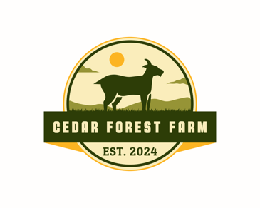
Cedar Forest Farm wedding venue prices:
1-50 people $350
51-100 people $500
*Parking is limited but available.

