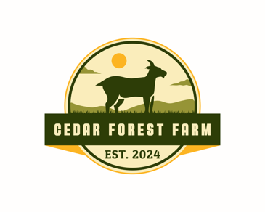
Cedar Forest Farm lumber prices:
Red Cedar $3.50 per board foot
Douglas Fir $2.50 per board foot
Hemlock $2.00 per board foot

